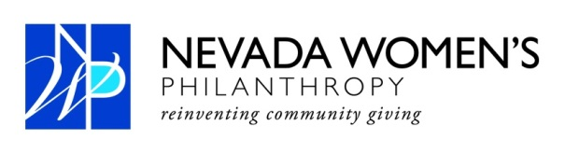
For Immediate Release Contact: Anne Kellogg
(702) 595-4985
kelloggal@gmail.com

Kelly Petersen named 2014 President of Nevada Women’s Philanthropy (NWP)
Las Vegas (Dec. 11, 2013) - Nevada Women’s Philanthropy (NWP) has named Kelly Petersen president of NWP and Tami Hance vice president.
Petersen has been an active member of NWP since she joined in 2008. She served the organization as treasurer from 2009 until 2012 where she oversaw member dues and grant accounts. Most recently she served as vice president for the 2013 grant cycle that ended in early November with a $350,000 grant to Nevada Partnership for Homeless Youth.
Petersen is co-founder of Helping Hands Surgical Care which provides free surgeries to Las Vegas area patients who are uninsured or underinsured. An entrepreneur who owns and operates multiple businesses, Kelly most recently created Shaggy Chic Inc, a grooming salon and treat boutique located in Tivoli Village.
NWP’s newly elected vice president, Tami Hance, is a founding member of the organization who has served as grant monitoring chair and board secretary. She is vice president of Destinations By Design.
Since it was created in 2005, NWP has gifted $2.88 million to non-profits in Southern Nevada. Under Petersen, NWP will enter into its ninth grant cycle that starts in the beginning of January. This year, 39 nonprofits have submitted letters of intent to the organization for the 2014 NWP grant.
Past grant recipients include a $350,000 grant to Goodwill of Southern Nevada. In 2011, NWP donated $325,000 to Salvation Army of Southern Nevada. In 2010, the Rape Crisis Center, and NWP Signs of Hope Counseling Center received $350,000. In 2009 Legal Aid Center of Southern Nevada, NWP Children’s Attorneys Project was awarded $325,000. The Public Education Foundation, Empowerment Schools Program received $450,000 in 2008. In 2007 Greater Las Vegas After-School All-Stars, Roundy Elementary School was gifted $320,000. The inaugural grant was awarded to Foundation for an Independent Tomorrow. It created the NWP Employment Project with $180,000. Each year, a $30,000 NWP Founders Gift is awarded to the finalist.
About NWP
The Nevada Women's Philanthropy (NWP) is a member driven, pooled fund, large impact grant making organization established to address the needs of the greater Las Vegas community. NWP’s membership consists of philanthropically motivated women, united by a powerful desire to address emerging issues facing our community in the areas of arts, education, environment, social services, and health. For more information, please visit www.nevadawomensphilanthropy.org.

