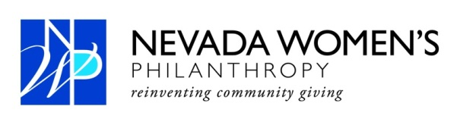
For Immediate Release Contact: Anne Kellogg
(702) 595-4985
kelloggal@gmail.com

Nazanin Ford named 2013 President of Nevada Women’s Philanthropy (NWP)
Las Vegas (Dec. 5, 2012) - Nevada Women’s Philanthropy (NWP) has named Nazanin Ford president, Kelly Petersen vice president, Melissa Attanasio treasurer and Julie Robinson secretary.
Ford has been an active member of NWP since 2008. She has served the organization as the education and events chair which oversees the annual grant celebration, education salon and member events. She has also served on the grant screening committee for four years. Most recently she served as vice president for the 2012 grant cycle which ended in early November with a $350,000 grant to Goodwill of Southern Nevada for the Veterans Integration Program.
"NWP is such an inspired movement in philanthropy,” Ford said. “I feel privileged to have been a part of the positive impact that it's had in our community for the last four years and I look forward to forging new partnerships that continue to empower and uplift our community in the year ahead."
Ford is one of the founders of the Pregnancy Foundation Las Vegas and currently serves on the board of the James Joseph Ford Foundation and Every Generation Gives.
Past NWP presidents include Carrie Henderson, Susie Lee, Dana Lee and Heather duBoef who founded NWP in 2005 and serves as its Chairman of the Board.
Since it was created in 2005, NWP has gifted $2.5 million to non-profits in Southern Nevada. Under Ford, NWP will enter into its eight grant cycle which starts in the beginning of January with a grant symposium open-house where NWP members and those from the non-profit sector meet to go over the NWP grant application details. Applications are due in February. NWP members then meet to select two grant finalists from the pool of applicants. The finalists present their ideas to the membership in October. A recipient is determined by popular vote. Each NWP member receives one vote.
Past grant recipients include a $325,000 donation to Salvation Army of Southern Nevada, the Rape Crisis Center, and NWP Signs of Hope Counseling Center received $350,000. In 2009 Legal Aid Center of Southern Nevada, NWP Children’s Attorneys Project was awarded $325,000. The Public Education Foundation, Empowerment Schools Program received $450,000 in 2008. In 2007 Greater Las Vegas After-School All-Stars, Roundy Elementary School was gifted $320,000. The inaugural grant was awarded to Foundation for an Independent Tomorrow. It created the NWP Employment Project with $180,000. Each year, a $30,000 NWP Founders Gift is awarded to the finalist.
About NWP
The Nevada Women's Philanthropy (NWP) is a member driven, pooled fund, large impact grant making organization established to address the needs of the greater Las Vegas community. NWP’s membership consists of philanthropically motivated women, united by a powerful desire to address emerging issues facing our community in the areas of arts, education, environment, social services, and health. For more information, please visit www.nevadawomensphilanthropy.org.
###

